**Josh Bevan**

**Vibrations: Project 3**

**Problem Overview**

The system consists of a 2-DOF system as depicted in Figure 1 with the following parameters:

M=1 lb-sec^2/in

C=10. lb-sec/in

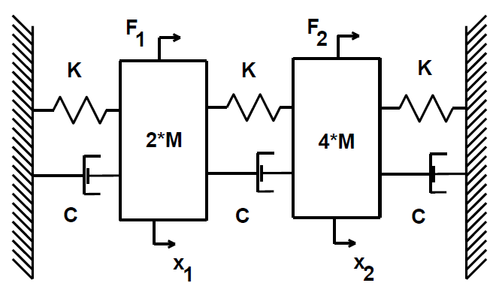K=10000lb/in)

Figure 1: Schematic representation of system under study

**Analytical Steady State Response *(g)***

**MATLAB Model: Transient Response of Physical System** ***(h)***

*Description of Model*

A model of the system in Figure 1 was developed in MATLAB. The equations of motion of the system were transformed into modal space to find an equivalent set of decoupled SDOF equations that were then translated into ODEs and solved using dsolve(). The resultant modal displacement was calculated, from which the total system response was calculated from the linear superposition of each mode. The script developed can be found in Appendix A.

*Results*

A comparison of the MATLAB model and SIMULINK in a later section yields virtually identical graphs as those from MATLAB alone, for brevity the original MATLAB plots can be found in Appendix B.

**SIMULINK Model: Transient Response of Physical System** ***(i)***

*Description of Model*

The equations of motion developed in Project 2 were used to create a SIMULINK model of the system. The displacement of each mass is output to the workplace to later be used for comparison to the MATLAB model. The time increment of the simulation was chosen to be the same as the MATLAB model. A schematic of the model used can be found in Figure 2.

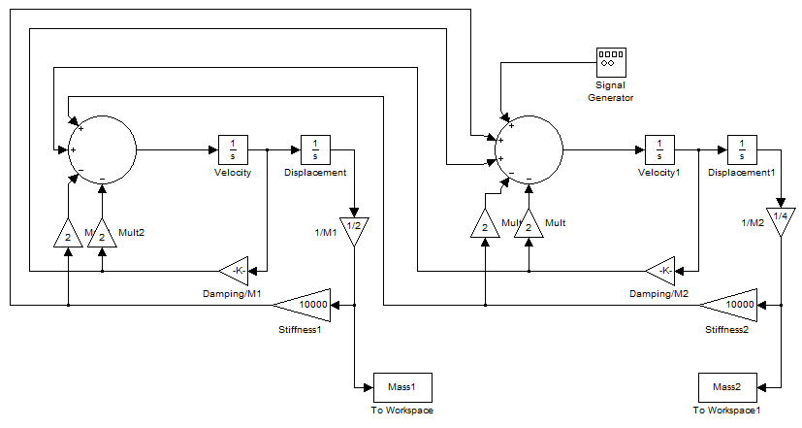

Figure : SIMULINK model developed to simulate 2 DOF system

*Results*

A comparison of the MATLAB model and SIMULINK in a later section yields virtually identical graphs as those from MATLAB alone, for brevity the original SIMULINK plots can be found in Appendix C.

*Comparison*

Using the MATLAB script displacements for each mass from each model were plotted. It was found necessary to plot one of the model’s results as a dotted line as the agreement is so good that one line completely hides the other. The comparison is plotted for mass 1 and 2 in Figures 3 and 4 respectively.

It is clear to see there is near perfect agreement across the time segment examined. The behavior of each mass follows closely what is qualitatively expected from theory. There is some transient response to the forcing function being “turned on” at t=0; This decays away eventually leaving only the steady state response of the system.



Figure : Comparison of transient response of displacement of mass 1



Figure : Comparison of transient response of displacement of mass 2

**SIMULINK Model: Initial Displacement Response *(j)***Using the previously developed SIMULINK model an initial condition of x1(0)=0.5 was applied the transient response of the system is plotted in Figure 5. The system initially has a response dominated by the initial condition. However as time passes the system transistions into a damped response dominated by the natural frequencies of the system. In order to investigate this further a plot of the ratio of amplitudes was genrated and can be found in Figure 6. The ratio approaches a particular value of time and it was observed that this ratio is nearly that of the ratio of amplitudes for the first mode shape.



Figure : Transient response for x1(0)=0.5



Figure : Dominant mode determination

**SIMULINK Model: Mono-modal Excitation *(k)***It is intuitively expected that an initial displacement of the system in the same shape as a mode shape will excite only that mode. This is borne out mathematically by realizing that by definition each mode is orthogonal to the other. Setting up an initial displacement equal to a mode shape ensures that due to orthogonality none of the stored potential energy will be available to excite other modes.  
  
To test this each mode shape was input as initial displacements for the SIMULINK model and the ratio of amplitudes was plotted with respect to time. Modes 1 and 2 are plotted in Figures 7 and 8 respectively below. As expected, the ratio of amplitudes in either plot matches the respective ratio of amplitudes for the mode shapes as tabulated in Table 1.

Table : Comparison of Ideal and Measured Mono-modal excitation ratios

|  |  |  |
| --- | --- | --- |
| Mode | Predicted | Measured |
| 1 | 0.7322 | 0.7321 |
| 2 | -2.7316 | -2.7320 |



Figure : Nearly pure mode 1 excitation



Figure : Nearly pure mode 2 excitation

**Appendix A: MATLAB Model code**

%%%%%%%%%%%%%%%%%%%%%%%%%%%%%%%%%%%%%%%%%%%%%%

%Josh Bevan 2013

%22.520 Vibrations

%

%Small script that solves for mode shapes and freqs of MDOF system

%The equations of motion are decoupled by transforming to modal space.

%The resultant system is created from the linear superposition of each SDOF

%mode shape and it's time-variant response.

%

%The displacement is plotted for each DOF, and compared to similiar data

%gathered from a SIMULINK model

clc

close all

%clear all

%Variable values

M=1;

K=10000;

C=10;

F=1;

%Initial matrices

MMatrix= [2*M 0;

0 4*M];

KMatrix= [2*K -K;

-K 2*K];

CMatrix= [2*C -C;

-C 2*C];

%Solve for mode shapes and natural freqs

[Shape,Freq]=eig(KMatrix,MMatrix);

w1=Freq(1,1)^(1/2);

w2=Freq(2,2)^(1/2);

%Transform to modal space

ModalM = Shape'*MMatrix*Shape;

ModalK = Shape'*KMatrix*Shape;

ModalC = Shape'*CMatrix*Shape;

ModalF = Shape'*[0;F];

%Setup desired time step and size of time-variant response matrix

timestep=0.0001;

t=0:timestep:2;

TotResponse=zeros(2,size(t,2));

for i=1:2

%Use symbolic solver to solve each now decoupled SDOF modal system

eqn=dsolve('(ModalMi*D2p)+(ModalCi*Dp)+(ModalKi*p)=ModalFi*sin(0.5*(w1+w2)*t)', 'p(0)=0','Dp(0)=0');

%Calculate numeric value of symbolic variables and substitute to calc actual value

ModalMi= ModalM(i,i);

ModalKi= ModalK(i,i);

ModalCi= ModalC(i,i);

ModalFi=-ModalF(i);

sol(:,i)=subs(eqn);

%Total response is the linear superposition of each modal response sigma{ u_i*p(t) } for all i

TotResponse=TotResponse+Shape(:,i)*sol(:,i)';

end

hold on

plot(t,TotResponse(1,:),'Color','red')

plot(t,-Mass1.signals.values,'--b')

title('1')

figure

hold on

plot(t,TotResponse(2,:),'Color','red')

plot(t,-Mass2.signals.values,'--b')

title('2')

**Appendix B: MATLAB Model Results**



Figure B1: MATLAB model displacement transient response for mass 1



Figure B2: MATLAB model displacement transient response for mass 2

**Appendix C: SIMULINK Model Results**



Figure C1: SIMULINK model displacement transient response for mass 1



Figure C2: SIMULINK model displacement transient response for mass 2